ULTRASONIC TESTING REPORT
Company/Client |  | NCOC N. V. |  | Project |  | ESKENE WEST |  | Location |  | NOS Unit-550
Line No/Tag No: |  | A1-550-VA-003 |  | Material |  | SA516 Gr.70, SA 333 Gr.6, SA350 LF.2 |  | Día × Nominal Thickness |  | According to table
Procedure No: |  | QP-11-UTT-Q01 Rev 02  GOST 28702-90 |  | Calibration Block |  | CS Step wedge |  | Probe  S/N |  | D7906-SM  1171297
 |  |  |  | Calibration block Range |  | 2.5-25.00 mm |  | Angle |  | 0º
Manufacturing Code |  | ASME Sec. VIII Div.1 |  | Calibration Temp |  | 33º |  | Frequency |  | 5 MHz
 |  |  |  | Object Temp |  | 33º |  | Size |  | 11 mm
Acceptance Standard: |  | Client specification |  | Correction factors |  | - |  | Crystal |  | Dual
Surface condition |  | Coated/uncoated |  | Couplant |  | Gel |  | Accuracy |  | ± 0,1 mm
S. No | Equipment/  Material Name |  | Manufacturer |  | Serial No |  | Calibration certificate No |  | Calibration Expiry date
 | A-scan UT |  | OLYMPUS DL-38 |  | 171421601 |  | 2113237 |  | 02-04-2020
 | Step wedge calibration block |  | NDE-TECH |  | NDE-8363 |  | 7439 |  | 09-05-2020
Job description:

- UT spot check performed. According to provided Scope of work
- Inspection performed on East, West, South, North, Top and Bottom from external and internal side.
- UT was done by Echo to Echo technique.

Notes:
N/A – not applicable.
FSH - Full Screen Height

DETAILS AND RESULTS
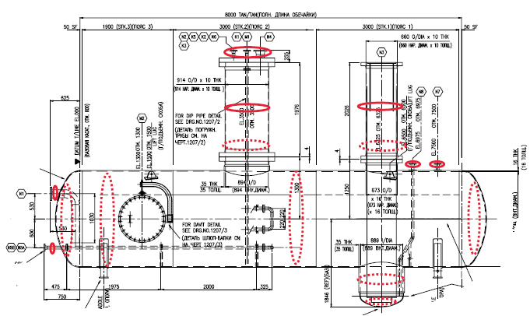
Shell 1
Shell 2
South Head
North Head
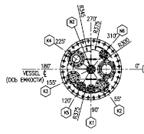 | 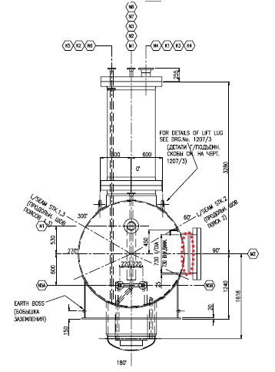

S/NO | Item description | Dia | Material | Nominal thickness, mm | East  mm | West  mm | South  mm | North  mm | Top  mm | Bottom  mm
 | M1 internal | 36’’ | SA-516Gr70 | 10.0 | 10.54 | 10.53 | 10.43 | 10.49 | - | -
 | M1 external | 36’’ | SA-516Gr70 | 10.0 | 10.50 | 10.48 | 10.51 | 10.46 | - | -
 | M2 | 30’’ | SA-350 LF2 | 20.0 | - | - | 19.71 | 19.86 | 19.22 | 19.09
 | N3 internal | 26’’ | SA-350 LF2 | 10.0 | 10.91 | 10.88 | 10.72 | 10.81 | - | -
 | N3 external | 26’’ | SA-350 LF2 | 10.0 | N/A | 10.43 | 10.41 | 10.39 | - | -
 | N8 | 2’’ | SA-350 LF2 | 8.74 | 8.77 | 8.41 | 8.77 | 8.53 | - | -
 | N7 | 2’’ | SA-350 LF2 | 8.74 | 8.84 | 8.74 | 8.52 | 8.92 | - | -
 | K4 | 6’’ | SA-350 LF2 | 10.97 | 10.94 | 11.15 | 11.26 | 11.18 | - | -
 | K1 | 2’’ | SA-350 LF2 | 8.74 | 8.53 | 8.44 | 8.68 | 8.57 | - | -
 | N6 | 2’’ | SA-350 LF2 | 8.74 | 8.43 | 8.61 | 8.70 | 8.53 | - | -
 | K2 | 4’’ | SA-350 LF2 | 11.13 | 10.66 | 10.73 | 10.70 | 11.16 | - | -
 | K5 | 2’’ | SA-350 LF2 | 8.74 | 8.55 | 8.63 | 8.72 | 8.58 | - | -
 | N2 | 2’’ | SA-333 Gr.6 | 8.74 | 8.62 | 8.51 | 8.47 | 8.74 | - | -
 | K3 | 4’’ | SA-350 LF2 | 11.13 | 10.75 | 10.97 | 10.42 | 10.53 | - | -
 | N1 | 6’’ | SA-516Gr70 | 10.97 | 10.88 | 11.90 | - | - | 10.78 | 10.81
 | N5A | 2’’ | SA-333 Gr.6 | 8.74 | 8.64 | 8.67 | - | - | 8.62 | 8.44
 | N5B | 2’’ | SA-333 Gr.6 | 8.74 | 8.56 | 8.48 | - | - | 8.57 | 8.71
 | N4 | 8’’ | SA-333 Gr.6 | 12.70 | 12.54 | 12.53 | 12.82 | 12.45 | - | -

Note: No access On the east side of nozzle N3 to take spot reading

S/NO | Item description | Dia,  mm | Material | Nominal thickness mm | Northmm | South mm | East  mm | Westmm | Center mm | Top  mm | Bottom  mm
1 | South head | ID2000 | SA516 Gr.70 | 16.0  min. 13.0 | - | - | 14.63 | 14.57 | 14.57 | 14.84 | 14.61
2 | Shell point 1 | ID2000 | SA516 Gr.70 | 16.0 | - | - | 16.41 | 16.76 | - | 16.63 | 16.65
3 | Shell point 2 | ID2000 | SA516 Gr.70 | 16.0 | - | - | 16.65 | 16.61 | - | 16.75 | 16.34
4 | North head | ID2000 | SA516 Gr.70 | 16.0  min. 13.0 | - | - | 14.70 | 14.74 | 13.85 | 14.84 | 14.48
5 | Sump Dished Head Plate | ID889 | SA516 Gr.70 | 13.00  min 9.0 | 13.61 | 13.61 | 13.62 | 13.59 | 13.24 | - | -
6 | Sump Neck | ID889 | SA516 Gr.70 | 35.00 | 34.52 | 34.36 | 34.12 | 33.96 | - | - | -

DETAILS AND RESULTS
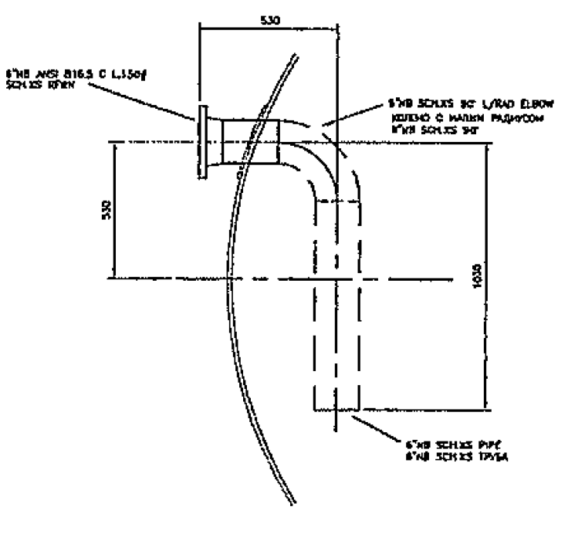
Pipe-1
Pipe-3
Elbow-2

S/NO | Item description | Dia | Material | Nominal thickness, mm | East  mm | West  mm | South  mm | Northmm | Top  mm | Bottommm | Extradosmm
1 | Pipe-1 | 6’’ | SA-516Gr70 | 10.97 | 11.03 | 10.53 | - | - | 10.62 | 10.49 | -
2 | Elbow-2 | 6’’ | SA-516Gr70 | 10.97 | 11.06 | 10.98 | - | - | - | - | 10.57
3 | Pipe-3 | 6’’ | SA-516Gr70 | 10.97 | 11.00 | 11.02 | 11.00 | 11.10 | - | - | -

DETAILS AND RESULTS
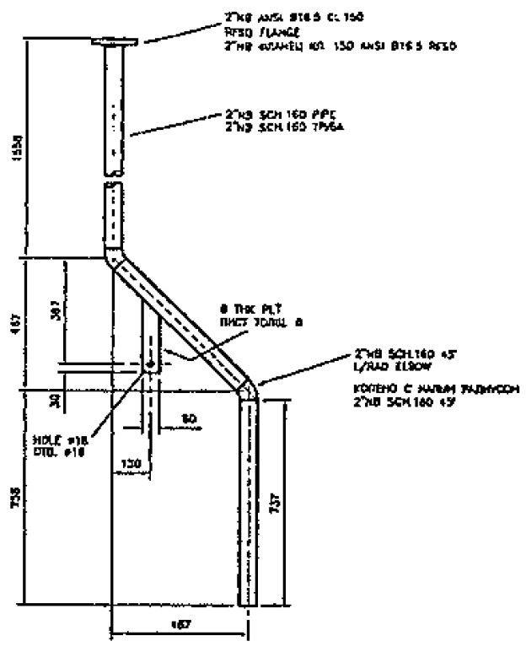
Ebow-2
Pipe-1
Pipe-3
Ebow-4
Pipe-5

S/NO | Item description | Dia,  mm | Material | Nominal thickness mm | Northmm | South mm | East  mm | Westmm | Bottom  mm | Top  mm | Extradosmm
1 | Pipe-1 | 2’’ | SA-350 LF2 | 8.74 | 8.67 | 8.77 | 8.50 | 8.67 | - | - | -
2 | Elbow-2 | 2’’ | SA-350 LF2 | 8.74 | - | - | 8.61 | 8.63 | - | - | 7.90
3 | Pipe-3 | 2’’ | SA-350 LF2 | 8.74 | - | - | 8.63 | 8.65 | 8.60 | 8.62 | -
4 | Elbow-4 | 2’’ | SA-350 LF2 | 8.74 | - | - | 8.47 | 8.88 | - | - | 8.15
5 | Pipe-5 | 2’’ | SA-350 LF2 | 8.74 | 8.73 | 8.81 | 8.41 | 8.46 | - | - | -

DETAILS AND RESULTS
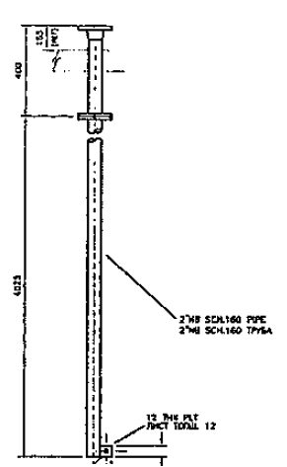
Pipe-1

S/NO | Item description | Dia, mm | Material | Nominal thickness mm | North mm | South mm | East mm | West mm
1 | Pipe-1 | 2’’ | SA-350 LF2 | 8.74 | 8.59 | 8.34 | 8.64 | 8.52

DETAILS AND RESULTS
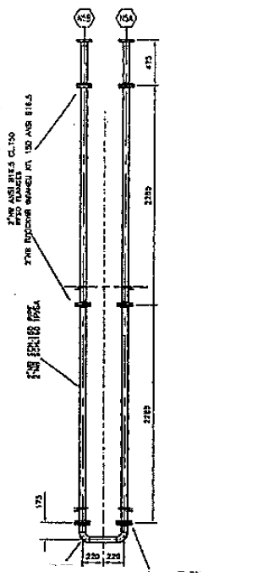
Pipe-2
Pipe-1
Pipe-6
Elbow-3
Pipe -7
Pipe-4
Elbow -5

S/NO | Item description | Dia,  mm | Material | Nominal thickness mm | Northmm | South mm | East  mm | Westmm | Bottom  mm | Top  mm | Extradosmm
1 | Pipe-1 | 2’’ | SA-333 Gr.6 | 8.74 | - | - | 8.49 | 8.52 | 8.33 | 8.53 | -
2 | Pipe-2 | 2’’ | SA-333 Gr.6 | 8.74 | - | - | 9.01 | 8.80 | 9.01 | 8.68 | -
3 | Elbow-3 | 2’’ | SA-333 Gr.6 | 8.74 | - | - | - | - | 8.33 | 8.67 | 8.04
4 | Pipe-4 | 2’’ | SA-333 Gr.6 | 8.74 | 8.55 | 8.34 | - | - | 8.40 | 8.44 | -
5 | Elbow-5 | 2’’ | SA-333 Gr.6 | 8.74 | - | - | - | - | 8.74 | 8.62 | 8.15
6 | Pipe-6 | 2’’ | SA-333 Gr.6 | 8.74 | - | - | 9.00 | 8.88 | 9.05 | 8.59 | -
7 | Pipe-7 | 2’’ | SA-333 Gr.6 | 8.74 | - | - | 8.50 | 8.45 | 8.42 | 8.62 | -

Examined by  UT L II cert. No 048  expiry date: 01.03.2020 | Name: Kosmukhambetov Rustembek | Signature: ............................. | Date: 25-August-2019
Approved by UT Level II  cer. No 1A 253/15  exp date: 31.05.2020 | Name: Shakunou Andrei | Signature: ............................ | Date: 25-August-2019
Client Representative: | Name: …………………………… | Signature: ............................ | Date: ……………

